Jorge Quezada

CSC 4370

June 15, 2020

Class Work 1

Local Web Server Screenshot

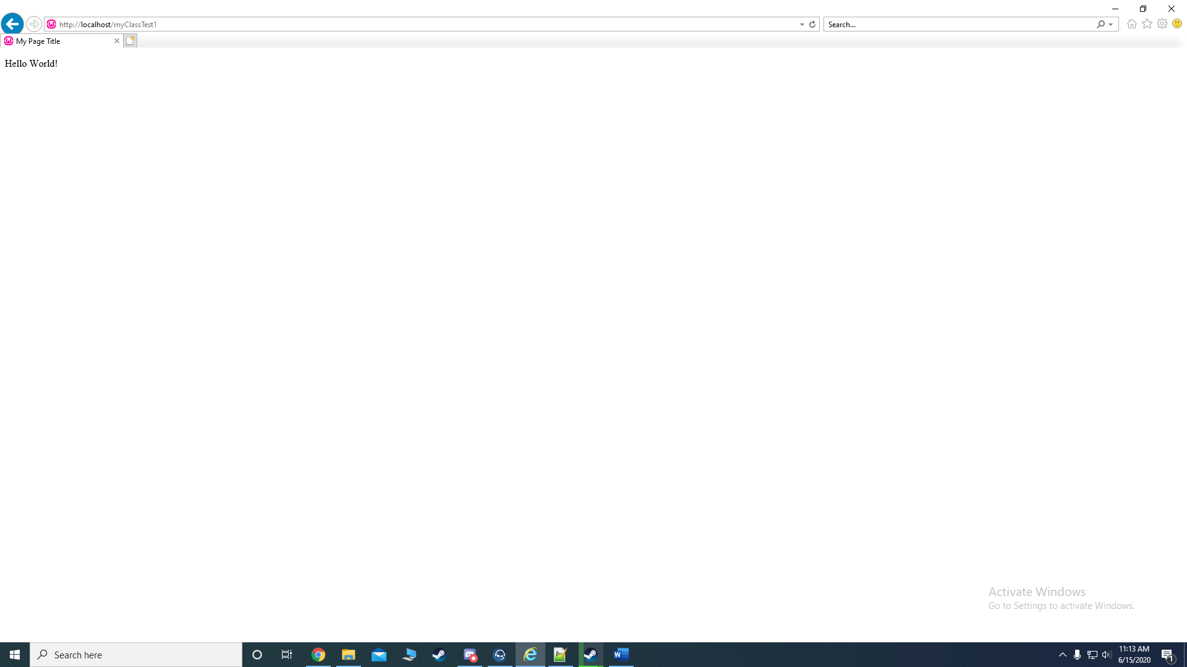

This was a screenshot of the error I get when I try to connect to the codd server.

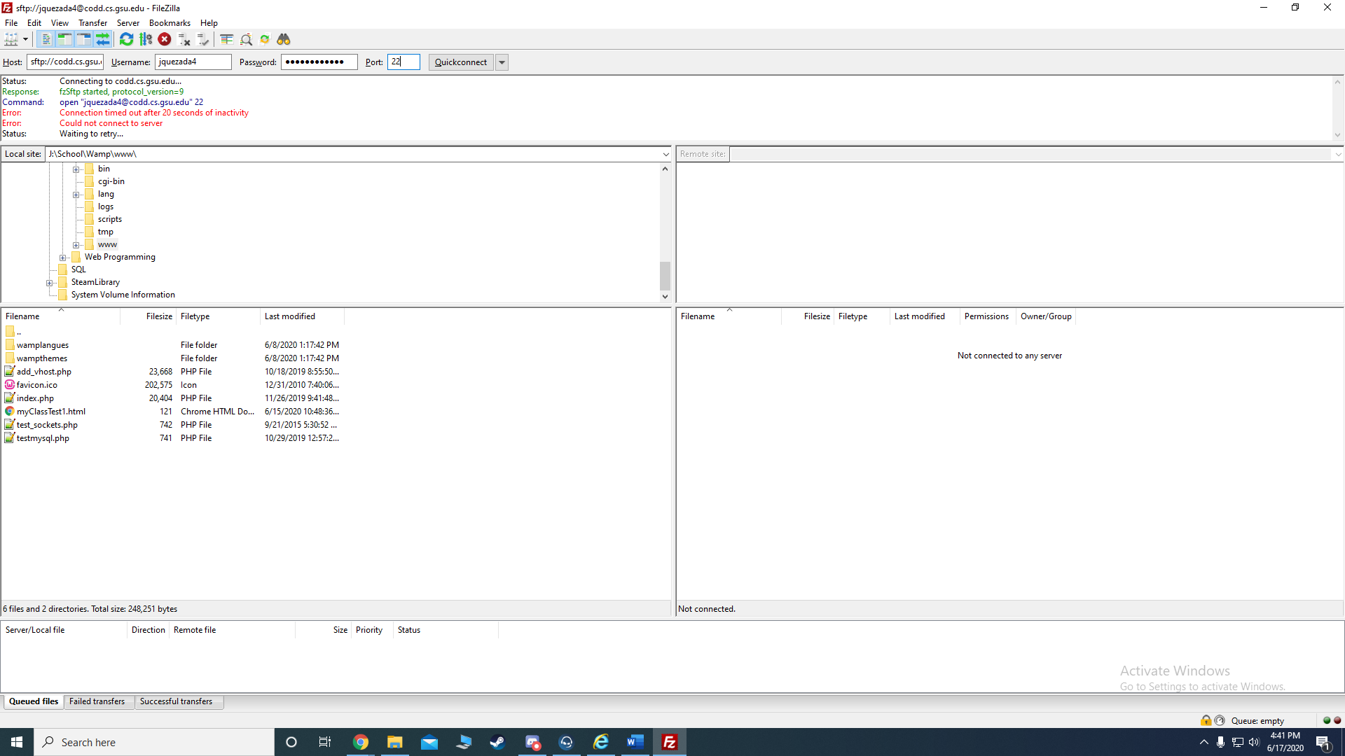

I had issues connecting to the CODD server. But as shown in the first screenshot, I was able to connect to my localhost and make the sample html page as well as show where it is in my folders in the second screenshot.